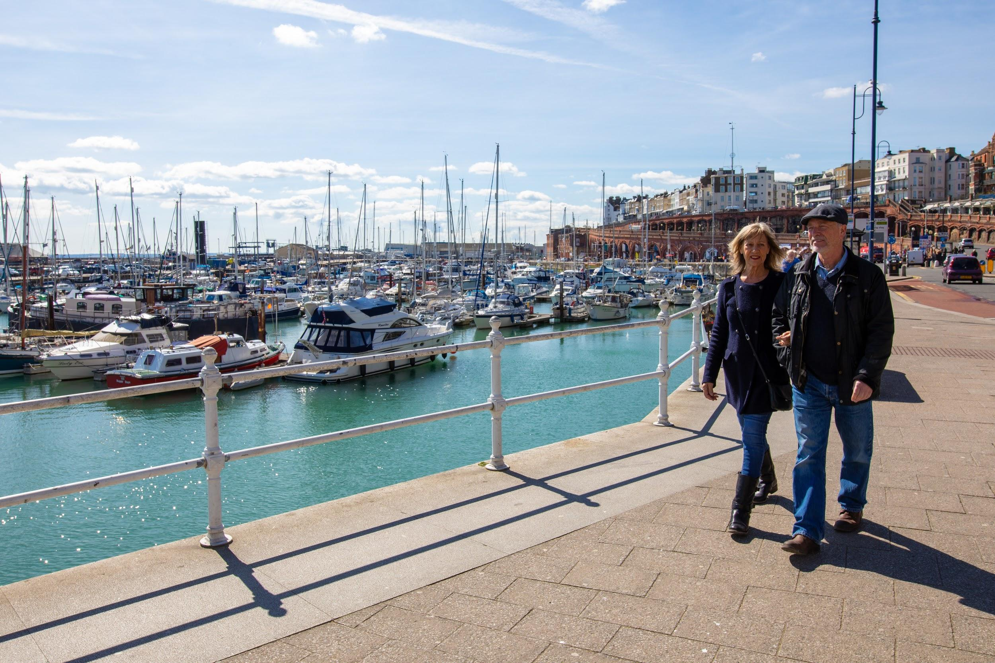
How to connect with visitors to Ramsgate?
• Older couples
• High proportion of recent repeat visitors
• Travel by car and a few by boat
• Stay with friends and relatives with low expenditure per trip
• Recreational activities are the biggest triggers for visitation
• Higher usage of leaflets and brochures.

WHO
• Visitors to Ramsgate are more likely to be couples (40% compared to 36% for Thanet) and the least likely to attract family units (22% compared to 27% for Thanet).
• Ramsgate attracts a lower proportion of children (13%) and young adults (16-24s account for 5%), whereas those aged 55+ account for 46% and 28% are over 65+ (the highest percentages of the three towns). As a result, Ramsgate attracts the highest proportion of retired visitors (37%).
• Ramsgate attracts a higher proportion regular(78%) and recent (42%,visited in the last six months).

HOW
• Most arrive by car (the highest for the three towns) and a few (2%) arrived by boat. Although boat users are a minority this is a form of transport that could be promoted, not least because the harbour was identified as the best thing about Ramsgate.
• High numbers of visitors to Ramsgate are likely to also visit Broadstairs during their trip. Day trips tend to be shorter than average (23% of visits lasted half a day only, compared to an average of 20% for Thanet) and, as a result, spend per day trip is also the lowest (£19.27 compared to £24.71 for Thanet). Overnight visitors are more likely to visit and stay with friends and relatives. Those using paid accommodation are likely to stay in hotels and self catering units and likely to book direct with accommodation providers.

How to connect with visitors to Ramsgate?

HOW MUCH
• This higher proportion of visitors staying with friends and relatives results in the lowest spend per overnight trip (£170.98) and per night £37.99, compared to £43.97 for Thanet). Spend on shopping and entertainment is also proportionally low.

WHAT
Recreational activities (water and outdoor sports, walking, cycling, etc.) are likely to trigger visitation. The harbour is perceived as being Ramsgate’s best area, described as being clean and tidy and with good access, being easy to get to and around it. Ramsgate achieved highest scores for the for ‘Traffic levels / congestion’ and ‘Pedestrian signposting’. These are important assets that help promote the area as a nice, clean and friendly place to visit.

Visitors to Ramsgate are more likely to use brochures and leaflets when planning their trips. Once in Ramsgate, they are the most likely not to use any additional types of information, probably because they might rely on details provided by friends and relatives.

CONNECT:
• Promote Ramsgate, and in particular the harbour area as a clean and tidy place, with good access and being easy to the to and around it
• Consider joint promotion of Broadstairs and Ramsgate as many will visit both locations during their trip
• Promote the beach and in particular the harbour area for good places to eat and drink as well as the opportunity for walking and cycling
• Ensure a good supply and distribution of leaflets and brochures
• Support additional accommodation
• Use a tone of voice according to the visitor profile

