Tourism Matters: Business Grants and Marketing Opportunities

Dear Tourism Industry Colleague,

This week we have news on the Local Restrictions Support Grants and the Closed Business Lockdown Payment. There are some marketing opportunities with VisitEngland and the National Coastal Tourism Academy, plus the opportunity to support local businesses by voting for them in the Taste of Kent Awards 2021.

If you know somebody who would like to read our e-news, please forward it on, or let them know they can register to receive it themselves on www.visitthanet.co.uk/tourismmatters

Thanet District Council
Foreshores and Coastline Public Space Protection Order Consultation
The Council has launched a live public consultation for all to have their say on the Foreshore and Coastline Public Spaces Protection Order 2021 running from Monday 25th January to Sunday 21st February.

The consultation is on two proposals which will affect how residents and visitors use and enjoy our Beaches and Coastline.

The first proposal is the introduction of a new Beaches and Coast Public Space Protection Order (PSPO), which is based on the current bylaws. The second proposal focuses on the way that Powered Water Crafts (PWC) access and use the coastline, alongside changes to the water user group.

Full details of the proposal can be found online. We would appreciate you completing the live questionnaire providing your thoughts and feedback.

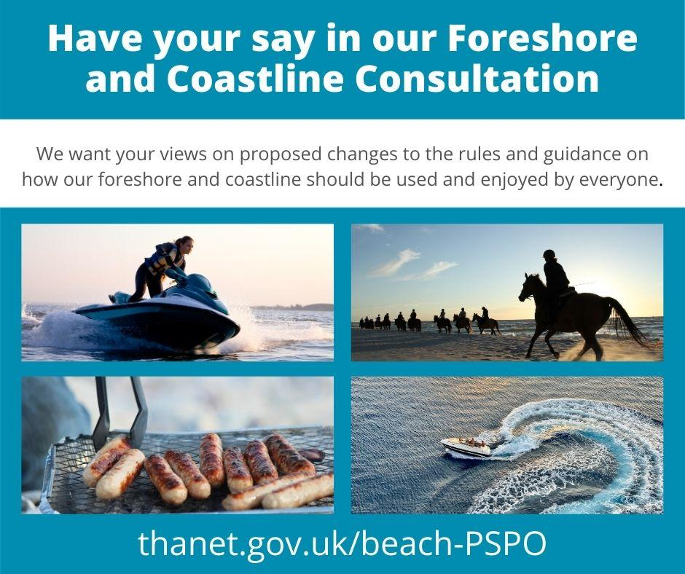

New Litter Stations
Thanet District Council are excited to announce new ‘TidyPac’ stations have been installed along Margate seafront in a partnership between the council and community litter action group, Rise Up Clean Up (RUCU).

The new stations are similar to the existing Tikspac dog waste bag dispensers, which were installed by the council across the district in 2017. The latest stations however are much larger in size, and provide a free recycled plastic bag to encourage people to collect litter instead. The stations aim to normalise the idea of litter picking and encourage everyone who visits the beach to do their bit.

The project has been made possible through a crowdfunding campaign led by RUCU, together with a £500 contribution from the council. Thanet District Council has also helped with the physical installation of the stations along the seafront.

Thanet District Council will be monitoring how successful these initial stations are with the hope to explore the possibility of installing more across the rest of our 19 miles of coastline. Read more here
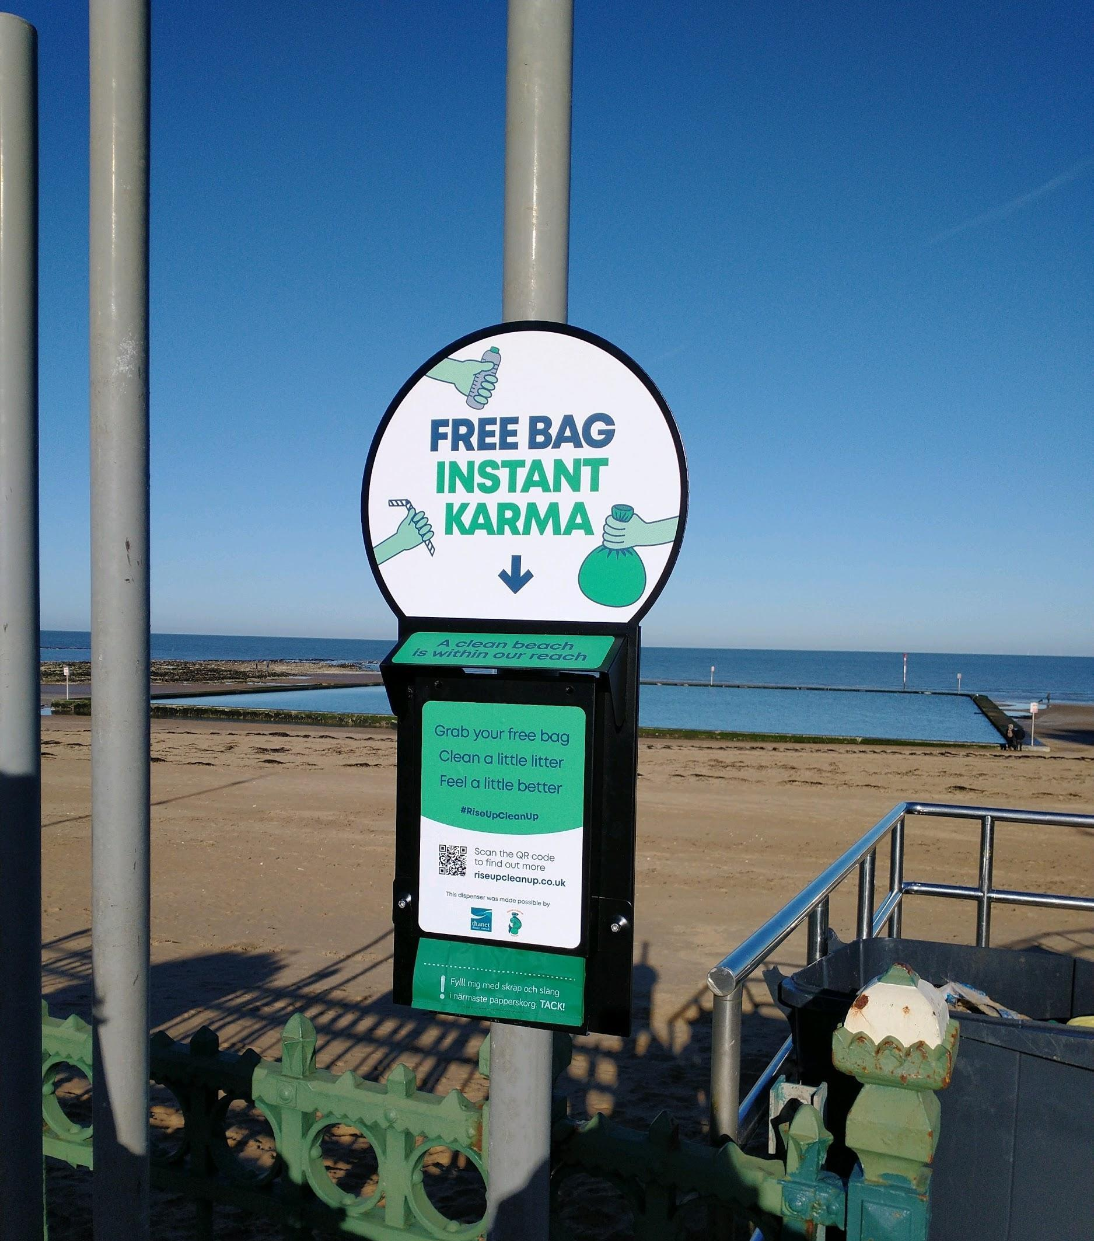

Ramsgate Future Highstreet Fund
On Saturday 26th December 2020, the Government announced Ramsgate as one of 72 areas across the country to be allocated funds from the £830 million Future High Streets Fund. The aim of the fund is to renew and reshape town centres and high streets, improving experience, driving growth and ensuring future economic sustainability.

Further information and updates about the Future High Street Fund, and what this investment will mean for the town and Thanet district, is available here. More will be published on thanet.gov.uk in the coming weeks.

Business Grants Update
For those businesses that were closed due to the local Tier 3 restrictions (2nd to 18th December), local Tier 4 restrictions (19th December to 4th January) and the national lockdown (5th January to 15th February) payments through the Local Restrictions Support Grants (LRSG (Closed) Addendum) will be made on Monday 1st February.

Most closed businesses will also receive the one-off top-up grant on the same day (£4,000 for businesses with a rateable value at or below £15,000, £6,000 to those with a value above £15,000 but below 51,000 and £9,000 above this level)

Where there are outstanding applications, the grants team is in contact to gather the required missing information.

Applications to cover the November national lockdown close on Sunday 31st January. Thanet District Council are unable to accept applications for this scheme after this date and all payments must be by Sunday 28th February.

The Additional Restrictions Grants scheme payments covering local Tier 3 restrictions, local Tier 4 restrictions and the national lockdown have been made.

Further one-off payments (depending on the businesses rateable value) have been made this past week (up to Friday 29th January). The team is still working through some outstanding applications.

The Christmas Support Payments for wet-led pubs (those who derive less than 50% of their sales from food) of the 142 applications received 122 have been paid and there are no outstanding applications. Applications for this scheme close on Sunday 31st January 2021.

To find out more about the grants and to apply, visit the Thanet District Council website

For more information and details of other business support available:
- visit our COVID-19 business support pages
- email highstreets@thanet.gov.uk to sign-up for updates direct to your inbox
- request to join our Thanet Business Support Facebook Group
- call the business support line (03333 602300), delivered by the Kent & Medway Growth Hub, between 8:30am and 5pm Monday – Friday.
Government Advice
New guidance on coronavirus funding schemes
New Government guidance is available on two coronavirus funding schemes - the Local Restrictions Support Grants (LRSG (Closed) Addendum) and the Closed Business Lockdown Payment.

Tourism and hospitality venues in England that have been required to close, as well as businesses that operate primarily as an in-person venue, but which have been forced to close those services and provide a takeaway-only service instead may be eligible for one or both of these grants. Eligible businesses must occupy the property on which they pay business rates and be the ratepayer.

For those required to close due to the national restrictions beginning Tuesday 5th January 2021, the Closed Businesses Lockdown Payment (CBLP) supports eligible businesses based on the rateable value of the property on the first full day of restrictions.
- Businesses with a property with a rateable value of £15,000 or less, may be eligible for a one-off cash grant of £4,000.
- Businesses with a property with a rateable value over £15,000 and less than £51,000, may be eligible for a one-off cash grant of £6,000.
- Businesses with a property with a rateable value of £51,000 or above, may be eligible for a one-off cash grant of £9,000.
Businesses that were open as usual, but then required to close due to national restrictions imposed by government (for each period) may be eligible for the LRSG (Closed) Addendum schemes:
- From Tuesday 5th January 2021 onwards
- Between Saturday 5th November and Friday 2nd December 2020
The grant will be based on the rateable value of the property on the first full day of restrictions.

For National restrictions from Tuesday 5th January 2021
- Businesses with a property with a rateable value of £15,000 or less, may be eligible for a cash grant of £2,001 for each 42-day qualifying restrictions period.
- Businesses with a property with a rateable value over £15,000 and less than £51,000, may be eligible for a cash grant of £3,000 for each 42-day qualifying restrictions period.
- Businesses with a property with a rateable value of £51,000 or above, may be eligible for a cash grant of £4,500 for each 42-day qualifying restrictions period.
For National restrictions between Saturday 5th November and Friday 2nd December 2020
- Businesses with a property with a rateable value of £15,000 or less, may be eligible for a cash grant of £1,334 for each 28-day qualifying restrictions period.
- Businesses with a property with a rateable value over £15,000 and less than £51,000, may be eligible for a cash grant of £2,000 for each 28-day qualifying restrictions period.
- Businesses with a property with a rateable value of £51,000 or above, may be eligible for a cash grant of £3,000 for each 28-day qualifying restrictions period.
The grants are administered by local councils. Details can be found on the Thanet District Council website

Find out what financial support you can get

VisitBritain/VisitEngland
We’re Good to Go industry standard update
VisitEngland have confirmed they will be retaining the We're Good to Go programme for the next few months to aid business recovery. The industry standard and supporting mark means businesses across the sector can demonstrate that they are adhering to the respective Government and public health guidance, have carried out a COVID-19 risk assessment and check they have the required processes in place. The scheme is free to join and open to all businesses across all tourism industry sectors.

VisitEngland have worked with other government departments to ensure that they alert local teams in enforcement that a business who has signed up to We’re Good to Go understands what guidance they need to follow and is receiving regular updates on the latest Government guidelines.

All those (over 40,000 across the UK) who have already signed up will receive an e-alert from VisitEngland on what they need to do to up-date their entry and download a personalised certificate.

If you have signed up to We’re Good to Go, please make sure you are using the standard across your marketing channels to help you further. VisitEngland are looking forward to continuing to work with you in these challenging times. Find out more about We’re Good to Go.

Be Part of Escape the Everyday at Home
VisitEngland are shining a spotlight on English businesses’ virtual attractions and experiences across their social channels during lockdown, to keep England top of mind for when visitors can travel again.

If you have content around VisitEngland’s key themes – seasonal fun, local flavour and learning more, share your stories with them for potential inclusion in the campaign.

You can also join the campaign by sharing content on your own channels with the hashtag #EscapeTheEveryday (at home). To find out more about the campaign and how to get involved click here

We would love to hear from you if you have anything to support the campaign that we can consider for our own social media and content. We will be looking at this is term of what we can supply ourselves

FREE - National Coastal Tourism Academy Opportunities (NCTA)
Market your business to domestic and international visitors for free
Through our partnership marketing and PR activity with NCTA, there is an opportunity for you to market your business to domestic and international visitors for free!

England’s Coast, the consumer facing side of NCTA, is a one-stop shop for visitors looking to explore our coastline. It’s funded by VisitEngland and listing your business on the website couldn’t be simpler - it’s free and can be updated at any time.

England’s Coast has just launched a major promotional and PR campaign to attract UK visitors to the coast so it will be gaining extra attention over the next few months. Previous campaigns generated more than £22m of media coverage – so make sure your business is listed today!

If you want added sparkle, you can upgrade your business to a Promoted Listing for just £200 + VAT. Enhanced listings appear higher in the search results, include additional images, the opportunity to add a special offer, and will be valid until March 2022.
To make your listing click here

Free online product knowledge training - Become an England’s Coast Ambassador for your area!
In preparation for when we are able to travel again, learn top tips and facts on your local area by completing England’s Coast Ambassador, a free online training course with modules for every region of our coastline.

Each section is packed with information on local attractions, the surrounding area and how to get around, ending with a short quiz. On completion applicants gain a downloadable England’s Coast Ambassador personalised certificate.

So put your local knowledge to the test and get your certificates now! Click here to start

Business Impact Survey
The National Coastal Tourism Academy (NCTA) has produced a new business survey to help them provide evidence for the need for additional support for businesses and to understand the current national picture on the coast. The data will be presented to the Government to give up-to-date insight on the impact of Covid-19 on the coastal visitor economy and the need for continued investment to ensure the survival and recovery of the sector.

Previous waves of the survey have been presented to Government inquiries, Ministers, MPs and government departments to raise awareness of the issues and get extra support for businesses on the coast.

We will be encouraging as many local businesses as possible to complete this survey with the aim of getting comparison results for Thanet, which we can share with our local MPs and politicians. With this in mind, we wondered if you would be willing to help us by agreeing to complete this survey either as a one-off, or ideally bi-monthly, to help us keep our fingers on the pulse of how our local industry is faring and where help is needed.

We have looked through the survey and in our opinion it is one of the quickest and simplest to complete for the amount of information gathered, so we would really appreciate your assistance with this.

Vote for Thanet Businesses in Taste of Kent Awards 2021
Voting is open until Sunday 28th February for the 2021 Taste of Kent Awards. Local businesses who have been shortlisted include
- Beer of the Year - NorthDown Brewery Margate and Ramsgate Brewery
- Food Retailer of the Year - Chef and Butcher Broadstairs
- Bakery or Confectionery Product of the Year - Birchington Bakery, Gina’s Old Kent Market,
- Hospitality Business of the Year - Arya Ramsgate, Bethany’s Cafe and Sandwich Bar Westgate, Bottega Caruso Margate

Find out more about the awards, the full list of nominees and to vote visit the Taste of Kent Award website. Support our wonderful Thanet businesses by voting for them

Tourism and Visitor Services News
Don't forget to follow us and share
If you are not already doing so, don’t forget to follow us @VisitThanet on Twitter, Facebook and Instagram where we have been sharing DidYouKnow facts, old images of the area and inspirational content for when visitors are able to travel

Plus, remember to tag us in, on your posts so we can like and share your content too.

What’s New and Anniversaries 2022
We may just be into 2021 but we would like to hear if you have anything new of touristic appeal planned for 2022, or if your venue is celebrating a key anniversary. This information will be used in our PR activities and will appear on our website and in social media posts where relevant. Please send information and images to tourism@thanet.gov.uk

Your News
Congratulations to Angela’s, Margate which has recently been recognised as a Michelin Green Star Restaurant. This distinction highlights restaurants at the forefront of the industry when it comes to their sustainable practices and who act as role models. Read more here

Wyatt and Jones, Broadstairs and Hantverk and Found have been highlighted as restaurants that are closed due to the lockdown but are still offering takeaway and/or delivery by the Michelin Guide

Congratulations to Quex Livery Glamping Holidays, who have been shortlisted in ‘Glamping Business of the Year’ of the Beautiful South Tourism Awards 2020/2021. The awards will be announced on Thursday 4th March. Good luck to them

