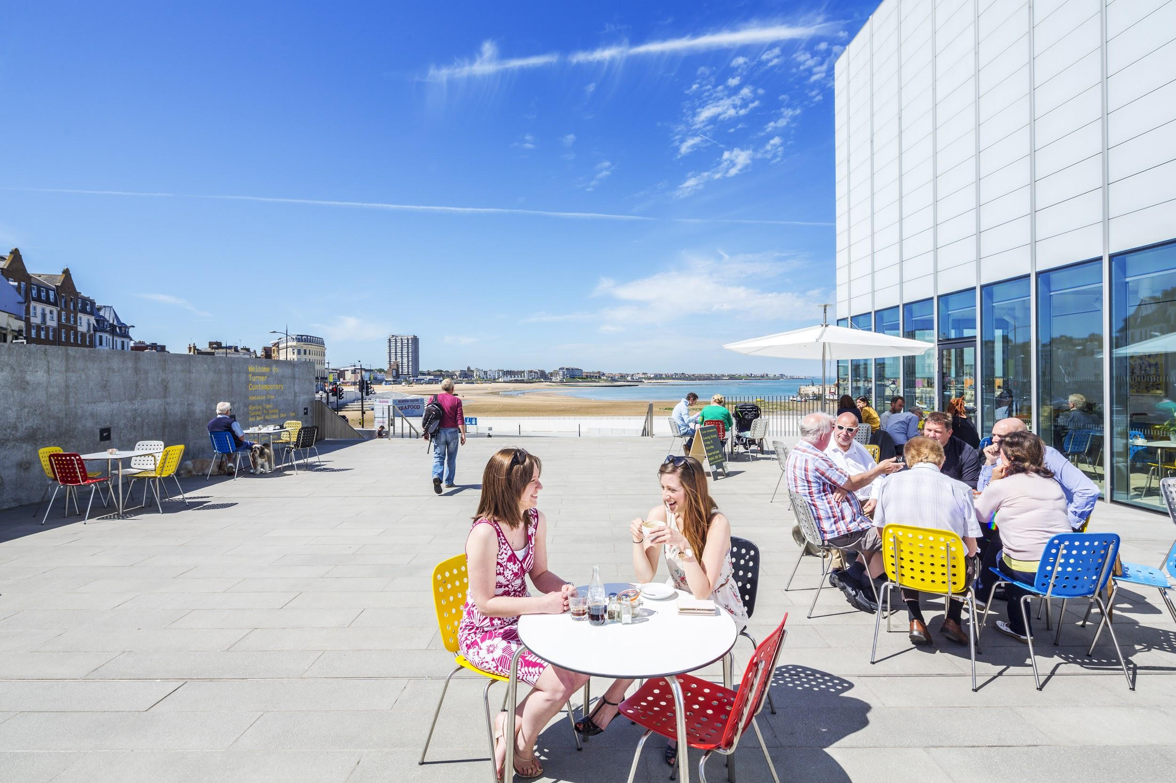
How to connect with visitors to Margate?
• Younger visitors
• Travel by train
• Serviced accommodation and Airbnb
• High levels of expenditure on accommodation and on entertainment
• Attractions and arts & culture biggest triggers for visitation
• Higher usage of destination websites and social media

WHO
• Visits to Margate often comprise of younger visiting groups - 25% are under 24s and 10% fall under, in the 16-24 age group. Overall, 53% of visitors are under 45s. Margate attracts the highest proportion of visitors in employment (73%) and the lowest proportion of retired visitors (21%)
• Margate attracts a higher proportion of first-time visitors (25% compared to 22% for Thanet as a whole). It also attracts a slightly higher proportion of visits by groups of friends, students and those travelling alone (31% compared to 27% for Thanet).

HOW
• Most arrive by car but visitors to Margate are significantly more likely to travel by train (30% compared to 19% for Thanet). The lower car usage results in the highest scores for availability of cost of parking
• Overnight visitors are more likely to stay in Margate itself (30% compared to 27% for Thanet). Higher proportions of overnight visitors will stay in serviced accommodation establishments (39% stayed in hotels or B&Bs) or self-catering, specially via Airbnb (16%). Accommodation providers in Margate achieve the highest scores for quality of service and value for money.

HOW MUCH
• This choice of accommodation results in a shorter duration of trip (3.6 nights per trip) but the highest spend per night (£50.63) compared to the average for the three towns (£43.97), driven by higher spend on accommodation but particularly on entertainment (£7.21 per person compared to £3.97 for Thanet).

How to connect with visitors to Margate?

WHAT
• Visitor attractions and arts and culture are the two biggest influencers when deciding to visit Margate. Not surprisingly, almost half (47%) had or planned to visit Turner Contemporary and a third (34%) had visited Dreamland (or intended to do so), which are the biggest triggers for visitation.
• Visitors to Margate will use destination websites and other websites / search engines when planning their trips but will also rely on recommendations from friends and relatives. Once in Margate, they are the most likely to use the destination’s website and social media channels.

CONNECT:
• Promote rail links – but remember this will encourage more day visitation
• Ensure quality of accommodation remains high
• Support additional accommodation
• Maximise the potential of Turner Contemporary and Dreamland as triggers for future visitation
• Promote events and harness the opportunities provided by Margate as a dynamic destination
• Make sure destination websites and social media have the latest and most up to date information about things to do in Margate
• Use influencers to inspire visitation
• Use a tone of voice according to the visitor profile

